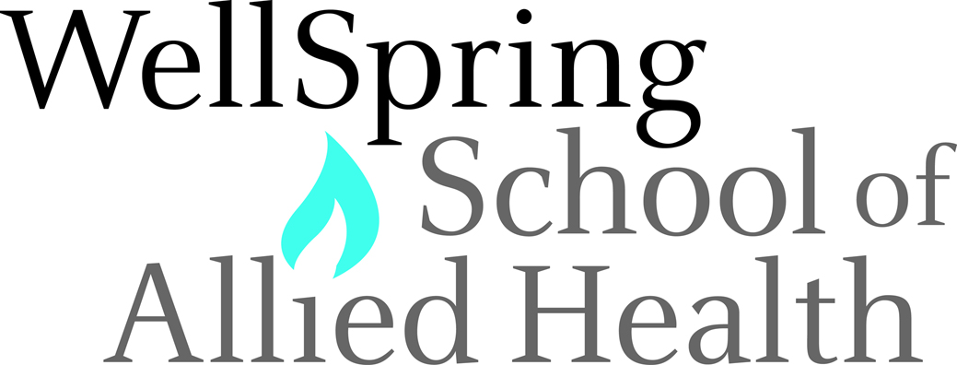

9140 Ward Parkway │ Suite 100 │Kansas City, Missouri 64114 │ 816 523 9140 │ wellspring.edu

REFERRAL & MENTORSHIP PROGRAM APPLICATION

To refer a student and apply to become a WellSpring mentor for the student you are referring, please fully and accurately complete the form below. If you only want to refer a student and earn our referral voucher, please contact our admissions department. There is no need to complete this form for a referral only.

My Name
Street Address
City ST ZIP Code
Home Phone
Work Phone
E-Mail Address
Name of Student being Mentored
Student Street Address
Student City, State, Zip
Student Phone
Student Email
Student Program

References
- _____________________________________________________________________________

- _____________________________________________________________________________

Qualifications/Employment History

Summarize Employment History and qualifications you have acquired from employment, previous volunteer work, or through other activities, including hobbies or sports that you believe is relevant to being a mentor.

Current Employer:

Employment History:

Other Qualifications

As part of the Wellspring mentoring process, the mentor agrees to fulfill, at minimum, the following requirements:
- Meet with the student once every two months while the student is in the program
- Meet with the program director at the midpoint of program to discuss student’s progress and achievement.
- Upon graduation, meet with the student once a month for 3 months to help with networking, interview skills, and general industry knowledge.
- Keep a log of all meetings and log must be signed by you and the student.

Agreement and Signature

By submitting this application, I affirm that the facts set forth in it are true and complete. I understand that if I am accepted as a mentor, any false statements, omissions, or other misrepresentations made by me on this application may result in my immediate dismissal from the mentorship program.

As part of the agreement, WellSpring will issue a $100 referral voucher once the referred student has completed the first module of their training, and three months after the mentored student has completed the program, and I have completed all requirements above, Wellspring School of Allied Health will disburse to me a mentoring fee of $500.

Name (printed)
Signature
Date

.

